January Newsletter Vol. Vol. 2
Tri-County Beard & Mustache Society
334 West 6th Street, Lapel, Indiana, 46051
Website: Tricountybms.weebly.com
E-mail: Tricountybms@yahoo.com
Twitter: TriCoBeard&Mustache@TCBeardMustache
Facebook: Tri-County Beard & Mustache Society
To all of you bearded beauties, mustachioed men, and beauties behind the men:
Everyone knows that our process has been a slow one. We are happy to say we have come such a long way since we began only a year ago. We are finally to the point that we plan on starting to help children this 2016-2017 school year. We now have a total of thirteen standard members and seven support members, but just like the facial hair we need to keep it growing!!!!!!!!!!

What’s been going on
Since our last newsletter in June, we have had a lot of big things happen. We had our first Beard and Mustache Competition and it was a HUGE success!! We have received more support in the form of memberships. We have participated in several vendor events that have helped us gain memberships, sponsorships for our t-shirts, donations, and not to mention getting our name and purpose out there. We have also got a great amount of instruments donated, which will hopefully be put to use by some children during the 2016-2017 school year. We finally got our mustache wax made and Bastin Honey Bee Farm is carrying our wax to sell. Serendipity Hair Salon in Pendleton and American Beauty in Fountain Square carry our beard oils. You can also find these products on our website as well as eBay!

Great Connections Are Being Made
We have made a great connection with Rick Singleton at Slick Music Studio in Anderson. He wants to funnel his instruments through us and he will offer discounts on lessons to children that we send to him. He also gave us part of a room to store all of our instruments in and we can call and tell him when and what instrument needs fixed up and he will get it ready for us. We have some potential leads for doing a podcast and also doing a beard and mustache competition in Kokomo at The Coterie. Although we are still waiting to hear back, Reverend Peyton’s Big Damn Band has said that they want to work with us!!!

What do we need from you as a member?

We need to continue selling our products and getting more memberships. Take donations! Get the word out, let people know what were about, tell them to check out our website or come to an event. These are some items that we have to offer:

- Support memberships
- Standard memberships
- Beard oil
- Mustache wax
- Vinyl Stickers
- T-Shirts

What are we still working on?
We would like to get a Golf outing together sometime this year, and we apologize it just didn’t work out to have one last year. We are putting on the finishing touches for our lease agreement and applications and plan to start offering our services to children in the 2016-2017 school year. We are ALWAYS working on increasing our funds. More funds mean more repairs, lessons, and instruments for our local youth!

Let’s keep the society and facial hair growing!!!!!!! 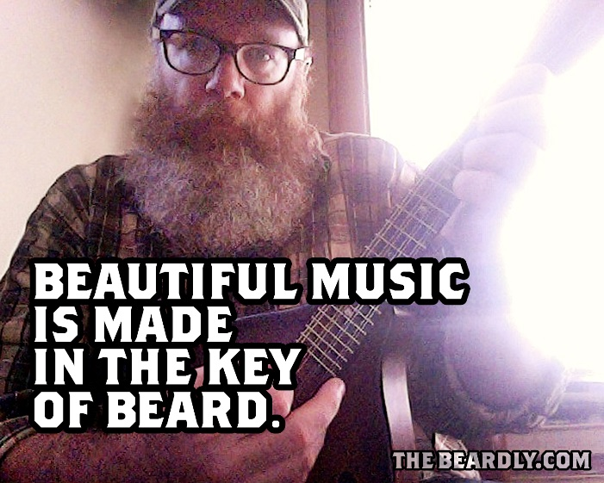

2016 Proud Sponsors
- Slick Music Studio
- The Stampede String Band
- Thomas Wayne Pruitt
- Bastin Honey Bee Farm
- 4Star Graphic Design
- Megan Hopkins Music
- Teachers Credit Union
- GameXchange
- Rhodes Realty
- Lapel Eagles #4323
- Chris Crafton
- Slim & Neaner
- Dave & Kelly Avenatti
- Caity Robertson

