July 2015 Newsletter Vol. 1
Tri-County Beard & Mustache Society
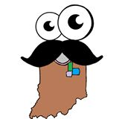

Upcoming Events

August 27
Meeting @ Lapel Eagles

September 11
Pendleton Heritage Fair
September 12
Pendleton Heritage Fair

September 24
Meeting @ Lapel Eagles
October 15
Meeting @ Lapel Eagles
October 24
Beard and Mustache Competition @ Lapel Eagles
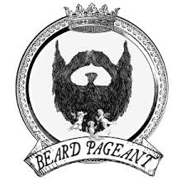

334 West 6th Street, Lapel, Indiana, 46051
Website: Tricountybms.weebly.com
E-mail: Tricountybms@yahoo.com
Twitter: TriCoBeard&Mustache@TCBeardMustache
Facebook: Tri-County Beard & Mustache Society
To all of you bearded beauties, mustachioed men, and beauties that support them:
Everyone knows that the process of building our society is not a very fast one. We are happy to say we have come a long way since we first began. We now have a total of ten standard members and five support members, but just like the facial hair we need to keep it growing!!!!!!!!!!

What’s Been Going On
We have had a lot going on since we started. Our biggest accomplishment has been getting our 501(3)(c) status to become a charity non-profit. This is all thanks to Mr. Chris Crafton and his very generous donation. You can now make in-kind donations, monetary donations, etc., and receive a receipt for tax deductible purposes. We have also participated in our first fair, setting up a booth at the Lapel Village Fair. We secured the support of another member as well as a good amount of donations from the many people we spoke with. Special thanks to Marian Wren and Patricia Bontrager for donations of merchandise for us to raffle and earn even more donations for the musical needs of our youth!! We certainly appreciate it!
Great Connections Are Being Made
We have made a great connection with Rick Singleton at Slick Music Studio in Anderson. He wants to funnel his instruments through us and he will offer discounts on lessons to children that we send to him.
What Do We Need From You As A Member?
November 12
Meeting @ Lapel Eagles
December 10
Meeting @ Lapel Eagles

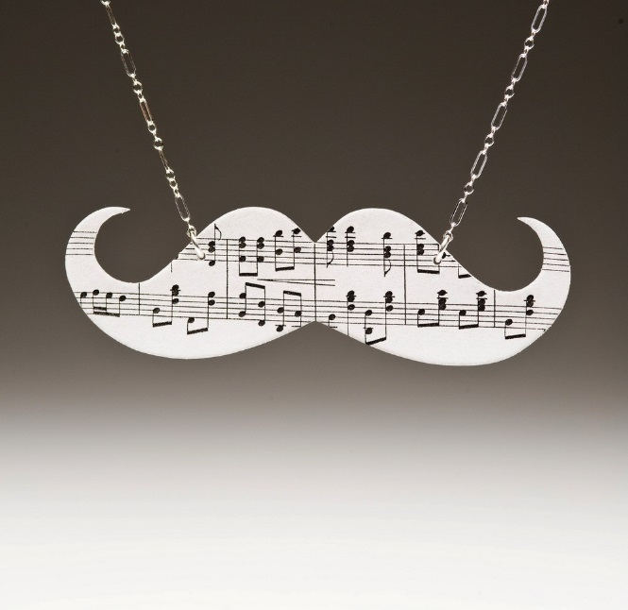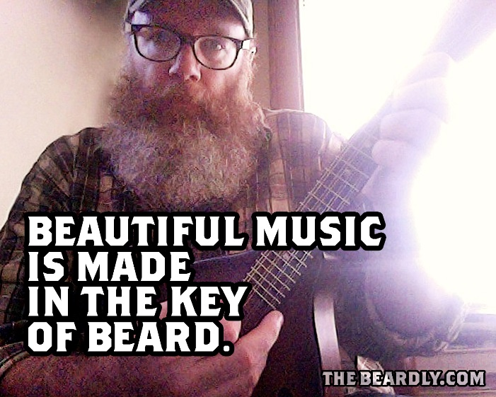

We need to continue selling our products and getting more memberships. Get the word out, let people know what we’re about, tell them to check out our website or come to an event. These are some of the items we offer:
- Support memberships
- Standard memberships
- Beard oil
- Vinyl Stickers
- T-Shirts
We would really like to get some business sponsors!! They need to donate $100 or more and they will get their name on the back of our next t-shirt order, plus a lot of our products. Date due: Nov 2015. And remember, we are ALWAYS taking instrument donations!
What are we still working on?
Many, many things. Here are a few. We are trying to get some fundraisers going. We would like to do a fundraiser in each county. We hoped for a golf outing in mid-August, but we may not be able to accommodate that event this year. DEFINITELY next year. We are also still working on a mustache wax for us to sell, experimenting with new beard oil fragrances, and have a new oil to debut soon. As always, we are always trying to grow our budget as well as our beards! We’re open to suggestions!
Let’s keep the society and facial hair growing!!!!!!!
